

**PURBANCHAL UNIVERSITY**

**HIMALAYAN WHITEHOUSE INTERNATIONAL COLLEGE**

**PUTALISADAK, KATHMANDU**

**PROPOSAL**

**ON**

**“RESTAURANT MANAGEMENT SYSTEM”**

**SUBMITTED BY**

**Samrakshyan Lamichhane**

**Nischal Pandey**

**Dipsagar Chaudhary**

**SUBMITTED IN PARTIAL FULFILLMENT OF**

**THE REQUIREMENTS FOR THE AWARD OF DEGREE OF**

**BACHELOR OF INFORMATION TECHNOLOGY**

**(DEPARTMENT OF SCIENCE AND TECHNOLOGY)**

**DATE OF SUBMISSION: MARCH, 2024**

# Abstract

The Restaurant Management System is a Java based system designed to streamline and enhance the operations of Restaurants and similar establishments. With the growing demand for efficient management tools in the food service industry, the Restaurant Management System offers a user-friendly interface that empowers Restaurant owners and staff to effectively manage various aspects of their business.

The system provides modules for inventory management, order processing, employee scheduling, customer relationship management, and financial tracking. Through a centralized dashboard, Restaurant administrators can monitor stock levels in real-time, place orders with suppliers, and track ingredient usage for menu planning and cost control.

Order processing features enable staff to efficiently take and process customer orders, whether for dine-in, takeout, or delivery. The system supports customization of menu items, modifiers, and pricing, ensuring accuracy and flexibility in meeting customer preferences.

Restaurant Management System functionalities enable Restaurants to build customer loyalty through personalized promotions, rewards programs, and feedback mechanisms. By capturing customer preferences and behavior, Restaurants can tailor their offerings and marketing efforts to enhance customer satisfaction and retention.

Financial tracking tools within the Restaurant Management System facilitate accounting processes, such as tracking sales, expenses, and profits. Detailed reports and analytics provide valuable insights into the Restaurant's performance, helping owners make informed decisions to drive growth and profitability.

In conclusion, the Restaurant Management System offers a comprehensive solution for Restaurants seeking to improve operational efficiency, enhance customer experience, and achieve business success in a competitive market landscape.

# Table of Contents

Abstract I

Table of Contents II

List of Figures IV

List of Abbreviations V

Chapter 1: Introduction 1

1.1: Background 1

1.2: Problem Statement 2

1.3: Objectives 3

1.3.1: General Objectives 3

1.3.2: Specific Objectives 3

1.4: Scope and Limitations 4

1.4.1: Scope 4

1.4.2: Limitations 4

Chapter 2: Literature Review 5

2.1: Study of Existing System: 5

2.2: What is new in our project? 6

Chapter 3: System Analysis 7

3.1: Requirement Analysis 7

3.1.1: Functional Requirements 7

3.1.2: Non-Functional Requirements 7

3.2: Feasibility Analysis 8

3.2.1: Technical 8

3.2.2: Economic 8

3.2.3: Operational Feasibility 8

3.2.4: Time Feasibility: Gantt Chart 8

Chapter 4: System Design 10

4.1: SDLC model 10

4.2: Selected Model 10

4.3: Context diagram 12

4.4: DFD 13

4.5: ER-Diagram 14

4.6: Use Case Diagram 15

Chapter 5: Implementation and Testing 16

5.1: Implementation 16

5.1.1: Tools used 16

5.2: Testing 17

Chapter 6: Expected Outcome 18

6.1: Users 18

Chapter 7: Conclusion and Discussion 20

7.1: Summary of Findings 20

7.2: Implications 20

7.3: Future Work 20

Reference 21

# List of Figures

Figure 1: Gantt Chart 9

Figure 2: Context Diagram 12

Figure 3: Data Flow Diagram (DFD) 13

Figure 4: ER Diagram 14

Figure 5: Use Case Diagram 15

# List of Abbreviations

RDBMS: Relational Database Management System

IDE: Integrated Development Environments

SVN: Subversion

DFD: Data Flow Diagram

SDLC: Software Development Life Cycle

# Chapter 1: Introduction

## 1.1: Background

The Restaurant Management System project is a Java-based application developed to streamline the operations of Restaurants, enhancing efficiency and improving customer service. The system provides a user-friendly interface for Restaurant owners and staff to manage inventory, process orders, schedule employees, and maintain customer relationships.

Restaurant management involved manual processes for tasks such as inventory management, order processing, employee scheduling, customer engagement, and financial tracking. However, as Restaurants grow in popularity and complexity, these manual methods often prove to be time-consuming, error-prone, and limiting in terms of business insights.

With the rise of digitalization and the increasing demand for convenience, Restaurant owners and managers are seeking innovative solutions to simplify operations while maximizing profitability. The Restaurant Management System addresses these needs by integrating a range of functionalities into a single, user-friendly platform.

## 1.2: Problem Statement

Existing Problems:

1. **Manual and Tedious Tasks:** The current reliance on manual methods for tasks such as inventory tracking, order processing, and employee scheduling leads to inefficiencies, errors, and delays in service.
2. **Inventory Control and Cost Management:** Managing perishable ingredients, monitoring stock levels, and optimizing purchasing decisions are complex and critical for cost control and waste reduction.
3. **Inaccurate Order Processing:** Mistakes in taking and processing customer orders can lead to dissatisfied customers, wasted resources, and loss of revenue.
4. **Employee Scheduling Complexity:** Creating and managing employee schedules based on demand forecasts, availability, and labor regulations is challenging and time-consuming.
5. **Lack of Customer Engagement Tools:** Without effective customer relationship management tools, Restaurants struggle to build loyalty, offer personalized promotions, and gather feedback for continuous improvement.
6. **Limited Financial Insights:** Restaurant owners often lack real-time visibility into sales trends, popular menu items, and profitability, hindering their ability to make informed business decisions.
7. **Compliance and Regulation Concerns:** Restaurants must adhere to various labor laws, health codes, and financial regulations, adding complexity to operations and increasing the risk of non-compliance penalties.

## 1.3: Objectives

### 1.3.1: General Objectives

* To take orders
* To add item
* To remove item
* To edit item
* To display menu
* To show bill
* To display total sale reports

### 1.3.2: Specific Objectives

* Develop a user-friendly interface for Restaurant staff to efficiently take customer orders.
* Implement a system for processing dine-in and delivery orders seamlessly.
* Provide customization options for menu items, modifiers, and pricing.
* Enable customers to provide feedback, ratings, and reviews through the system.
* Implement secure login mechanisms for administrators, staff, and customers with role-based access control.
* Design an intuitive and responsive user interface for easy navigation and accessibility.

## 1.4: Scope and Limitations

### 1.4.1: Scope

1. **Order Management:**

* Creation and processing of dine-in, takeout, and delivery orders.

1. **Customer Relationship Management:**

* Customer database for storing contact details, preferences, and purchase history.

1. **Reporting and Analytics:**

* Generation of reports on sales, inventory, and employee performance.

1. **Menu Management:**

* Creation and editing of menu items with descriptions and prices.
* Categorization of menu items for easy navigation.

1. **User-Friendly Interface:**

* Intuitive and responsive interface for both staff and customers.

### 1.4.2: Limitations

1. **Hardware and Infrastructure:**

* System performance may be affected by the Restaurant's hardware specifications.
* Dependence on stable internet connectivity for online functionalities.

1. **Training and Adoption:**

* Staff training required for effective use of the CMS.

1. **Data Security:**

* Risks associated with storing sensitive customer data.

1. **Maintenance and Support:**

* Ongoing maintenance required for updates, bug fixes, and improvements.
* Availability of technical support and resources for troubleshooting.

1. **Customization:**

* Limited customization options within the predefined scope of the project.
* Requests for additional features may require extra development time and resources.

1. **Geographical and Language Limitations:**

* System availability may be limited to specific regions or languages.

1. **Offline Functionality:**

* Limited functionality in offline mode, particularly for online orders and updates.
* Dependency on internet connectivity for real-time data synchronization.

# Chapter 2: Literature Review

## 2.1: Study of Existing System:

The study of existing Restaurant management systems provides valuable insights into the current landscape of software solutions available for Restaurants. By analyzing the features, user interfaces, functionalities, and user experiences of these systems, it will help in designing and developing the Restaurant Management System project in Java to meet the specific needs and challenges faced by Restaurants. The findings will guide the project team in incorporating the best practices, addressing gaps, and delivering a robust, user-friendly, and efficient Restaurant Management System for Restaurant owners and managers.

**Challenges in Restaurant Management System:**

* **Customer Preferences:** One of the key challenges in the Restaurant industry is meeting customer demands and expectations. Customers today have become more selective and have higher expectations when it comes to their experience.
* **Staff Training:** Maintaining a skilled and motivated staff is essential for delivering high-quality service consistently. Staff retention and training issues can often hinder a Restaurant’s success.
* **Menu Selection and Pricing:** In a competitive market, [menu selection](https://blog.petpooja.com/cafe-menu-to-attract-customers/)and pricing can make or break a Restaurant’s success. Finding the right balance between offering diverse options while keeping prices reasonable is important.
* **Ordering Process:** Efficiently managing the ordering process is essential for customer satisfaction and operational efficiency. Long wait times and disorganized systems can frustrate customers and lead to lost business.

**User Interface Design:**

User Interface (UI) design plays a crucial role in the success and usability of the Restaurant Management System project in Java. An intuitive, user-friendly interface enhances user satisfaction, improves efficiency, and reduces the learning curve for Restaurant staff. Here are some key principles and elements to consider for designing the UI of the Restaurant Management System:

* Simplicity
* Consistency
* Visibility
* Feedback
* User-Friendly Language
* Responsive Design
* Accessibility

## 2.2: What is new in our project?

* **Utilization of Modern Technologies:**

Leveraging Java programming, our project harnesses the power of modern software development tools to create a robust and scalable solution.

* **Integration with Database Systems:**

By integrating with MySQL, our system ensures efficient storage and retrieval of customer information, menu, and billing system, enhancing data management capabilities.

* **Security and Compliance:**

With a focus on data security and compliance with privacy regulations, our system implements robust authentication mechanisms and encryption techniques to safeguard sensitive information and ensure regulatory compliance.

# Chapter 3: System Analysis

## 3.1: Requirement Analysis

In this section, the system's requirements are thoroughly analyzed to ensure a comprehensive understanding of the project's objectives and functionalities. The analysis encompasses both functional and non-functional aspects, serving as the foundation for the system design and development.

### 3.1.1: Functional Requirements

In this part, the specific features and functionalities that the Restaurant Management System must deliver to meet the needs of users and stakeholders are defined. These requirements are derived from stakeholder consultations, existing system assessments, and industry best practices. Some of the examples of functional requirements are:

* **Order Management**: The system allow staff to create new orders for dine-in, takeout, or delivery and enable customization of menu items, modifiers, and special requests.
* **Inventory Control:** The systemprovide tools to add, update, and remove items from the inventory and monitor real-time stock levels of ingredients and supplies.
* **User Authentication:** The system implement secure login mechanisms to authenticate users and grant appropriate access privileges based on their roles.

### 3.1.2: Non-Functional Requirements

Non-functional requirements specify the quality attributes and constraints that the system must attach to in terms of performance, security, usability, and scalability. These requirements ensure that the system meets user expectations and industry standards. Examples of non-functional requirements are:

* **Performance:** The system will respond to user actions promptly, with minimal latency, to provide a seamless user experience.
* **Security:** The system will employ encryption techniques and access controls to safeguard sensitive data and prevent unauthorized access.
* **Usability:** The system will feature an intuitive user interface with clear navigation and informative feedback to enhance user satisfaction and productivity.
* **Scalability:** The system will be scalable to accommodate future growth in terms of user base, data volume, and system complexity.

## 3.2: Feasibility Analysis

The feasibility analysis evaluates the viability of the Restaurant Management System project from technical, economic, operational, and time perspectives. This analysis helps assess the project's feasibility and identify potential risks and challenges that need to be addressed.

### 3.2.1: Technical

Technical feasibility assesses whether the project can be successfully implemented using available technologies, tools, and resources. It considers factors such as the compatibility of chosen technologies, the availability of skilled personnel, and the feasibility of integrating with existing systems.

### 3.2.2: Economic

Economic feasibility evaluates the cost-effectiveness of the project, taking into account the anticipated costs and benefits over its lifecycle. It involves cost-benefit analysis and budget considerations to determine whether the project is financially viable and justifiable.

### 3.2.3: Operational Feasibility

Operational feasibility examines the project's impact on existing processes, workflows, and organizational culture. It assesses the readiness of stakeholders to adopt and utilize the system effectively, considering factors such as training needs, change management, and stakeholder engagement.

### 3.2.4: Time Feasibility: Gantt Chart

Time feasibility evaluates the project's timeline and deadlines to determine whether it can be completed within the desired timeframe. It involves developing a project schedule, setting milestones, and identifying critical paths to ensure timely delivery of the system. 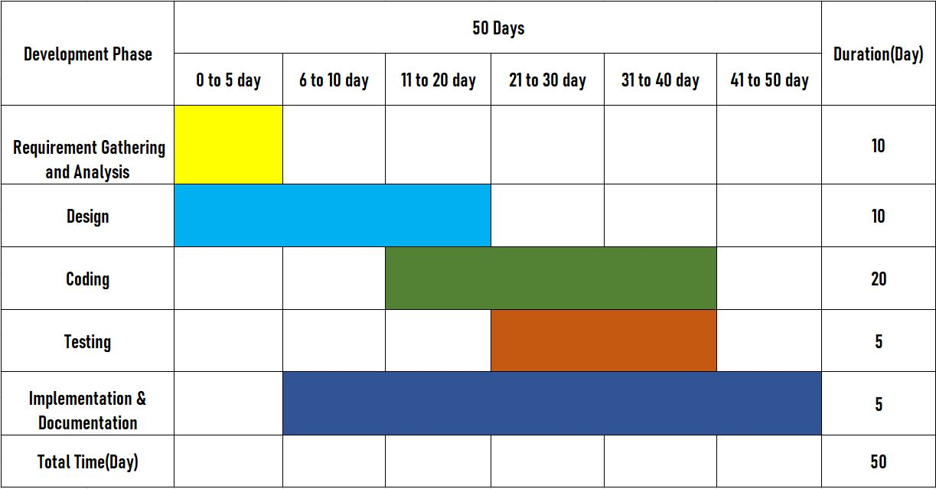**Figure 1: Gantt Chart**

# Chapter 4: System Design

## 4.1: SDLC model

In the context of a Restaurant Management System , the Software Development Life Cycle (SDLC) refers to the process followed to design, develop, test, deploy, and maintain the Restaurant Management System application. The SDLC model chosen for developing a Restaurant Management System can significantly impact the project's success, efficiency, and quality.

Using an SDLC model, such as Waterfall, in a Restaurant Management System helps ensure a structured and systematic approach to developing the software. This is crucial for managing the complexity of the project, coordinating the efforts of the development team, and meeting the specific requirements of the Restaurant system.

## 4.2: Selected Model

The Software Development Life Cycle (SDLC) for a Restaurant management system using waterfall model is: -

* **Requirements Gathering:**

Gather detailed requirements for the Restaurant management system, including features, functionalities, and user expectations.

* **Planning:**

Determine project scope, objectives, requirements, and constraints. This involves identifying the functionalities needed in the Restaurant management system.

* **Analysis:**

Gather and analyze requirements specific to the Restaurant management system. This includes understanding user needs, data flow, and system architecture.

* **Design:**

Create a detailed design of the system architecture, database schema, and user interface. Design the algorithms, use case diagram, flowchart and context diagram data structures required for efficient Restaurant management system.

* **Implementation:**

Write the code for the Restaurant management system using Java programming language. This involves creating classes, methods, and interfaces according to the design specifications.

* **Testing:**

Perform unit testing to ensure each component of the system functions correctly. Conduct integration testing to verify interactions between different modules. Also, carry out system testing to validate the entire blood bank management system.

* **Deployment:**

Deploy the Restaurant management system in a real-world environment. This may involve installation, configuration, and setup on servers or client machines.

* **Maintenance:**

Provide ongoing support and maintenance for the Restaurant management system. This includes bug fixes, updates, and enhancements based on user feedback and changing requirements.

Throughout the SDLC, it's crucial to follow best practices such as version control, documentation, and collaboration among team members to ensure the successful development and deployment of the Restaurant management system mini-project.

## 4.3: Context diagram

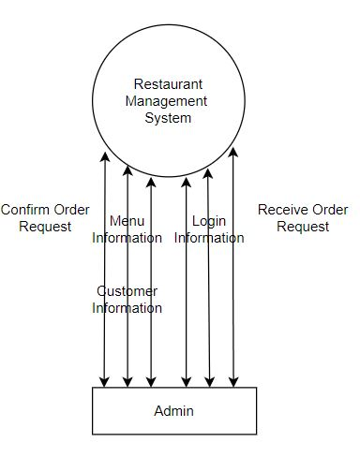

**Figure 2: Context Diagram**

## 4.4: DFD

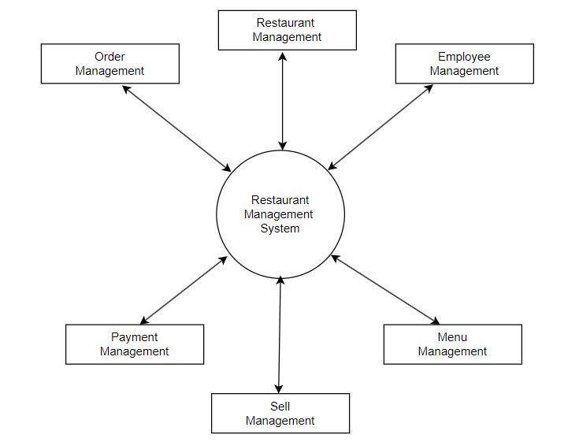

**Figure 3: DFD**

## 4.5: ER-Diagram

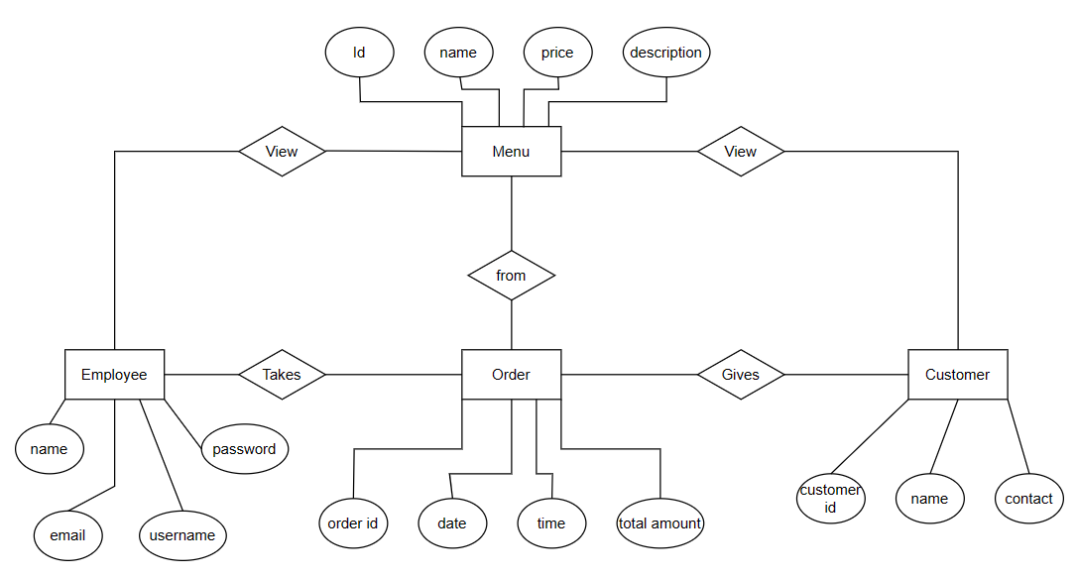

**Figure 4: ER-Diagram**

## 4.6: Use Case Diagram

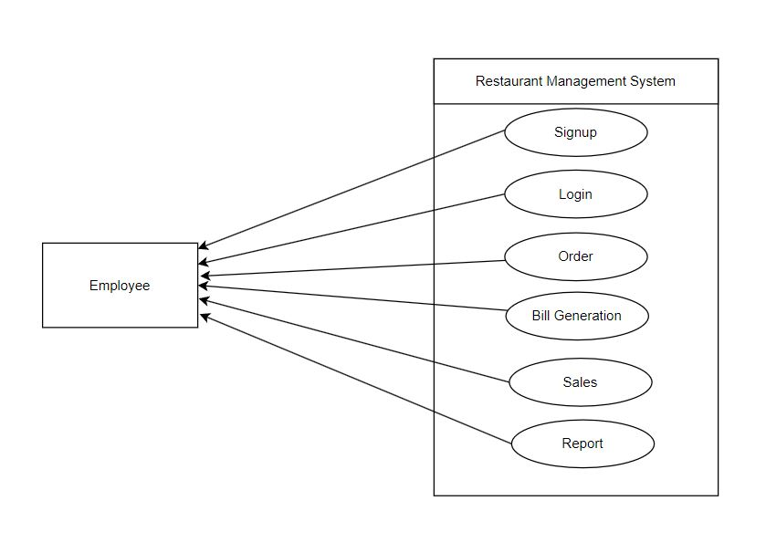

**Figure 5: Use Case Diagram**

# Chapter 5: Implementation and Testing

## 5.1: Implementation

Implementation refers to the actual development and coding of software components based on the design specifications. It involves using various tools and technologies to write code, build software modules, and integrate them into a cohesive system. During implementation, developers utilize IDEs (Integrated Development Environments) such as IntelliJ IDEA, Eclipse, or Visual Studio Code to write and manage code efficiently. These IDEs provide features like syntax highlighting, code completion, and debugging capabilities to streamline the development process.

Additionally, implementation involves the use of version control systems like Git, SVN, or Mercurial to manage source code changes and collaborate with team members effectively. Version control systems enable developers to track revisions, merge code changes, and maintain a history of project modifications.

### 5.1.1: Tools used

1. **Integrated Development Environment (IDE):**

* **Java:** Java was used for backend development, including business logic implementation and data processing.
* **XAMPP:** XAMPP is a software package that facilitates local web server setup for development and testing purposes.

1. **Database Management System (DBMS):** In the context of a Restaurant Management System, a Database Management System (DBMS) serves as the backbone for storing, managing, and retrieving all the data related to Restaurant operations. The DBMS plays a crucial role in ensuring that the Restaurant Management System functions efficiently, securely, and reliably.
2. **MySQL:** It is a widely used open-source relational database management system (RDBMS) commonly used to store and manage data related to orders, inventory, employees, customers, and other aspects of Restaurant operations.
3. **Version Control:**
   * **Git:** A distributed version control system for tracking changes in source code during development. Platforms like GitHub.

## 5.2: Testing

Testing for the Restaurant Management System involves verifying its functionality, reliability, security, and performance to ensure that it meets the requirements and expectations of users and stakeholders. Here are some key types of testing that can be performed for the Restaurant Management System:

1. **Unit Testing:**

Unit testing involves testing individual units or components of the system in isolation to ensure they perform as expected. For the Restaurant Management System, unit tests can be written to verify the functionality of modules such as orders, inventory, employees and customers.

1. **Integration Testing:**

Integration testing validates the interaction and interoperability of different modules or components of the system. In the context of the Restaurant Management System, integration testing ensures the interaction between the order management module and the inventory management module.

1. **System Testing:**

System testing evaluates the system's functionality against the specified requirements. Test scenarios can include verifying end-to-end scenarios such as placing an order, updating inventory, and generating a bill.

By performing comprehensive testing across these different areas, the Restaurant Management System can be thoroughly evaluated for quality, reliability, and usability, ultimately ensure Restaurant Management System meets quality standards, performance requirements, and user expectations.

# Chapter 6: Expected Outcome

## 6.1: Admin

1. **Login:**

* Outcome: Administrators can securely log in to the system using their credentials.
* Expected Result: Users are authenticated successfully and granted appropriate access privileges based on their roles.

1. **Placing an Order:**

* Scenario: Customer places an order for a latte and a croissant for dine-in.
* Expected Output: Order is successfully processed and saved in the database. Order details include items (latte, croissant), quantities, prices, and status. Customer receives an order confirmation with the total amount to be paid.

1. **Updating Inventory:**

* Scenario: Staff updates the inventory to add 10 units of coffee beans.
* Expected Output: Inventory database is updated with the new quantity of coffee beans (previous quantity + 10). Updated inventory reflects correct item details (name, quantity, category).

1. **Customer Feedback Submission:**

* Scenario: Customer submits feedback about the Restaurant's service.
* Expected Output: Feedback form data is saved in the database with customer name, email, rating, and comments. Confirmation message is displayed to the customer acknowledging feedback submission.

1. **Viewing Sales Report:**

* Scenario: Admin requests a sales report for the month of February.
* Expected Output: Sales report is generated with data on total revenue, top-selling items, and trends. Report includes visual charts or graphs for easy analysis.

1. **Updating Menu Items:**

* Scenario: Admin adds a new item "Meat Lover Pizza" to the menu.
* Expected Output: New menu item " Meat Lover Pizza " is added to the database with price, description, and category. Menu display is updated to include the new item in the appropriate category.

1. **Handling Invalid Login Credentials:**

* Scenario: User enters incorrect username/password for login.
* Expected Output: System displays an error message indicating "Invalid username/password combination". User is prompted to re-enter login credentials.

# Chapter 7: Conclusion and Discussion

## 7.1: Summary of Findings

In summary, the Restaurant Management System project in Java with a MySQL database presents a robust, user-friendly, and feature-rich solution for Restaurants to modernize their operations and meet the demands of today's competitive market. By leveraging technology to automate and streamline tasks, Restaurants can focus on delivering exceptional service, enhancing customer satisfaction, and driving business growth.

## 7.2: Implications

1. **Efficient Operations:** The Restaurant management system streamlines various tasks such as order processing, inventory management, and employee scheduling, leading to improved operational efficiency. Automation of routine processes reduces manual errors, saves time, and enhances overall productivity.
2. **Convenience and Accessibility:** Customers benefit from convenient online ordering, table reservations, and delivery options. Easy access to menus, promotions, and loyalty rewards enhances the overall dining experience.
3. **Competitive Advantage:** Implementation of the Restaurant Management System gives Restaurants a competitive edge by modernizing their operations and offering advanced services. Enhanced customer experiences and efficient operations attract new customers and retain existing ones.

## 7.3: Future Work

* Efficient order processing for dine-in, takeout, and delivery orders.
* Real-time inventory updates to manage stock levels, reduce waste, and optimize procurement.
* Streamlined employee scheduling and task assignment to improve productivity and organization.
* Effective CRM tools for customer engagement, loyalty programs, and personalized promotions.
* Seamless table reservations for customers, enhancing their dining experience.
* Accurate billing and payment processing options for convenience and transparency.
* Comprehensive reporting and analytics to gain insights into sales, inventory, employee performance, and customer trends.

# Reference

1. Gupta, R., & Singh, A. (2022). "Restaurant Management System: Design and Implementation."
2. Oracle Corporation. (2022). "MySQL Documentation." <https://dev.mysql.com/doc/>
3. Spring Framework. (2022). "Spring Framework Documentation." <https://docs.spring.io/spring-framework/docs/current/reference/html/>
4. Java Documentation. (2022). <https://docs.oracle.com/en/java/>
5. MySQL. (2022). "MySQL 8.0 Reference Manual." <https://dev.mysql.com/doc/refman/8.0/en/>